**FLIGHT TO EGYPT – 4/26/2025**

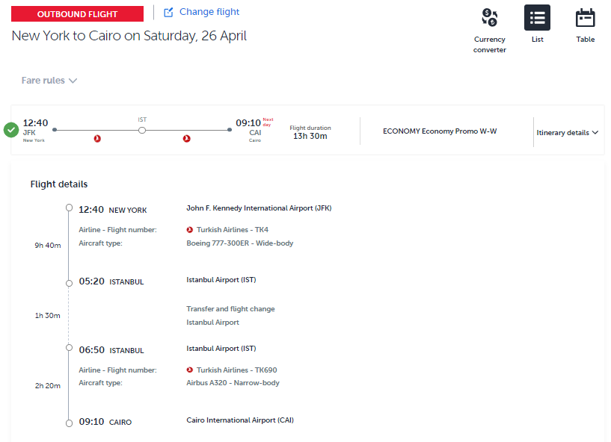

**FLIGHT LEAVING EGYPT – 5/4/2025**

